|  |  |  |  |  |  |  |  |  |  |  |
| --- | --- | --- | --- | --- | --- | --- | --- | --- | --- | --- |
| **Descriptive Statistics: Age, Sex, Eye, Diabetes, Pain** | | | | | | | | | | |
| **Variable** | **N** | **Mean** | **Median** | **TrMean** | **StDev** | **SE Mean** | **Minimum** | **Maximum** | **Q1** | **Q3** |
| **Age** | 558 | 64.018 | 65 | 64.257 | 6.944 | 0.294 | 45 | 75 | 59 | 69 |
| **Sex** | 558 | 1.5143 | 2 | 1.5159 | 0.5002 | 0.0212 | 1 | 2 | 1 | 2 |
| **Eye** | 558 | 1.5806 | 2 | 1.5896 | 0.4939 | 0.0209 | 1 | 2 | 1 | 2 |
| **Diabetes** | 558 | 7.9104 | 8 | 7.8825 | 1.6441 | 0.0696 | 5 | 12 | 7 | 9 |
| **Pain** | 558 | 2.5287 | 3 | 2.5239 | 0.5344 | 0.0226 | 1 | 4 | 2 | 3 |

**Table1**: Descriptive Statistics: Age, Sex, Eye, Diabetes, Pain

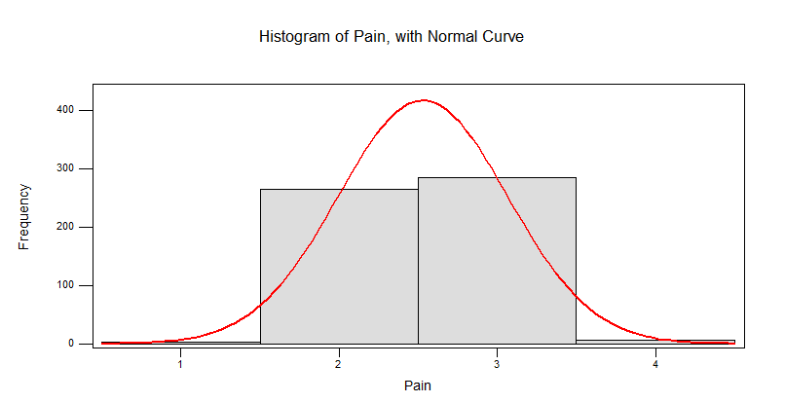

**Figure 1**: Histogram of Pain with normal curve

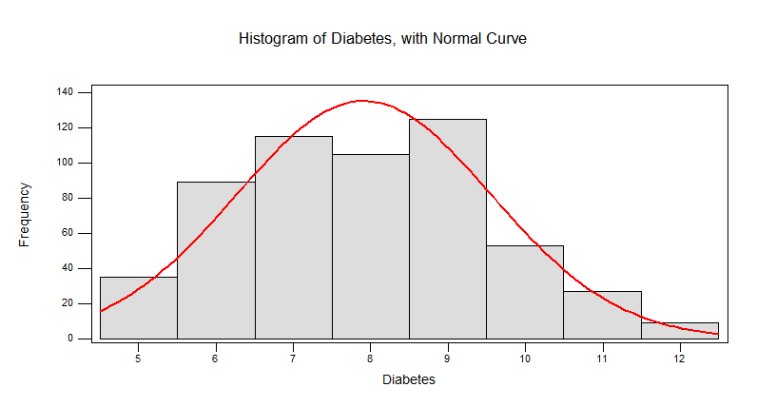**Figure 2:** Histogram of Diabetes with normal curve

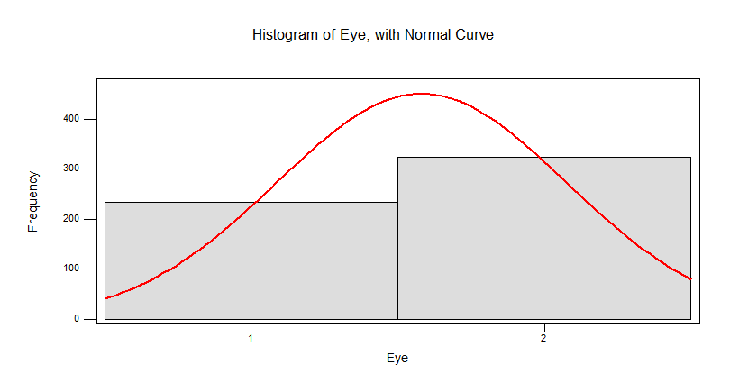

**Figure 3:** Histogram of eye with normal curve

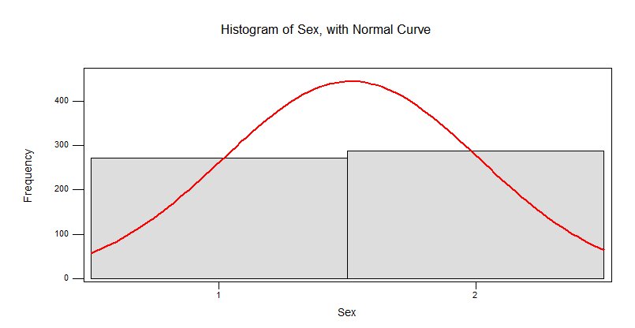

**Figure 4:** Histogram of Sex with normal curve

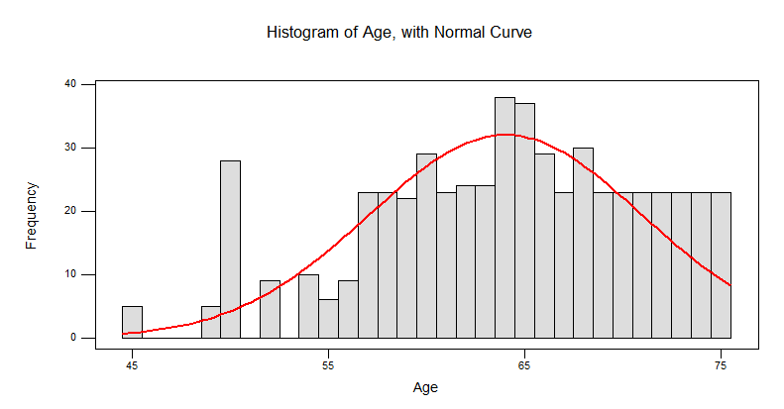

**Figure 5:** Histogram of age with normal curve

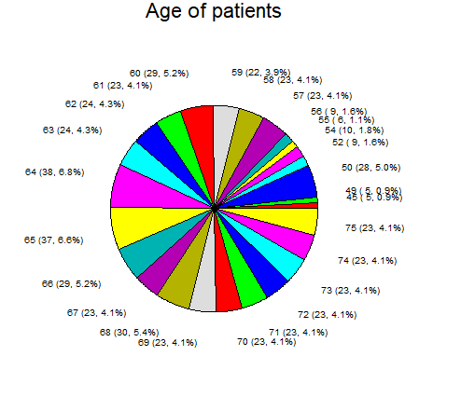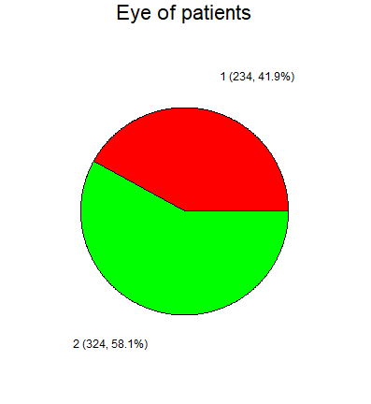

**Figure 7**: pie chart for age of patients (left) and eye of patients (right)

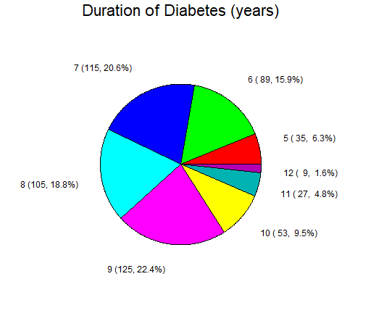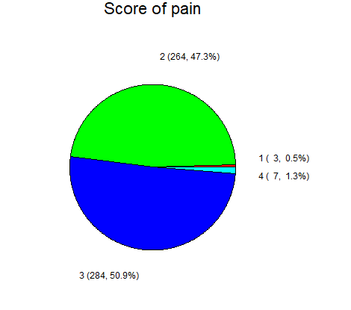

**Figure 8**: pie chart for duration of diabetes (left) and score of pain (right)